Maximum marks for Assignment: _________6______ Assignment Declaration Date:____________
Assignment Submission Date (on or before):______________________________
Assignment assessment declaration Date by faculty (on or before):________________________
Question NO | Question Statement | Level of mapping and Number |  |  | Blooms Level | Marks
Question NO | Question Statement | CO | PO | PSO | Blooms Level
Q1. | Explain term Mutation Testing | CO 2 | PO3 |  | 1 | 4
Q2 | Explain Software testing principles | CO 2 | PO1,PO2 |  | 2 | 4
Q3 | Design Test Strategy for any suitable example | CO 2 | PO2,PO3 |  | 3 | 6
Q4 | Short note on Test Planning & Test Strategy. | CO 2 | PO1 |  | 2 | 4
Q5 | How to find an test team efficiency | CO 2 | PO1,PO2 |  | 3 | 4
Q.6 | Describe important features of testing Process | CO 2 | PO4 |  | 2 | 4
Q.7 | Define the following terms  1.Error, 2. Defect , 3.Failures 4. Mistakes in S/w | CO 2 | PO1 |  | 1 | 6
Q.8 | Short note on requirement Traceability Matrix | CO 2 | PO1,PO2 |  | 2 | 4
Q.9 | What Skills required by a Tester. | CO 2 | PO4,PO5  PO11 |  | 2 | 4
Q.10 | Why independent testing team is required in organizations? | CO 2 | PO2,PO3 |  | 3 | 6
Q.11 | What is impact of defect in different phases of software development? | CO2 | PO1,PO2 |  | 3 | 3
Q.12 | What is bug tracking, bug fixing & bug verification? | CO2 | PO1,PO2 |  | 2 | 3
Blooms level no | Blooms Taxonomy terms
6 | 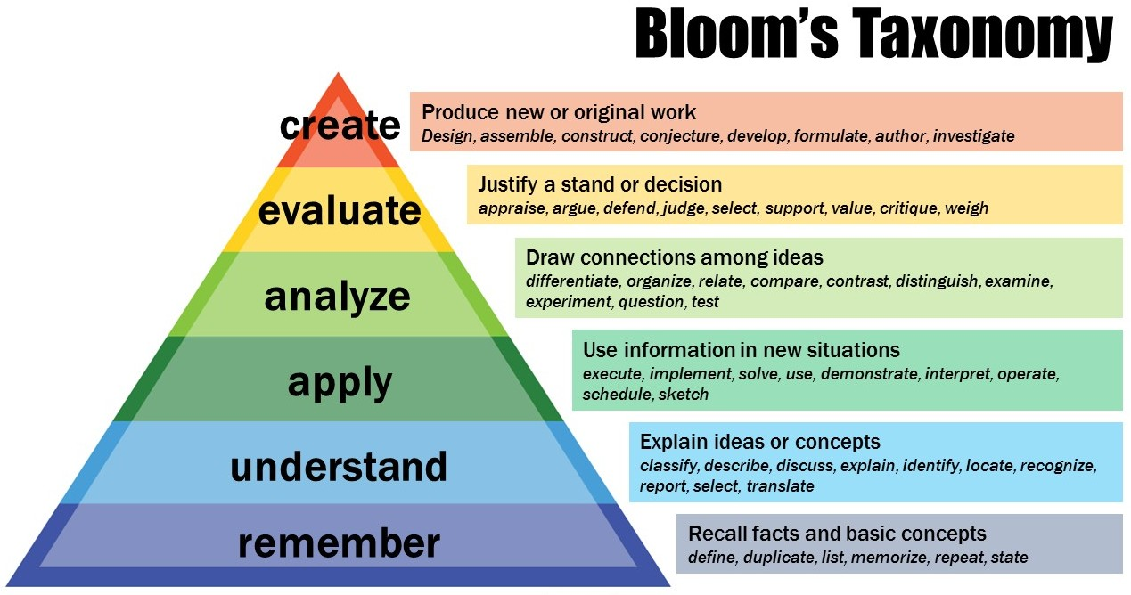
5
4
3
2
1

Subject In-charge HOD

